Week 8 – Task 2.2

A spectrogram based analysis gives us the advantage of analysing the frequency changes over time of a particular track, while a waveform only displays amplitude changes over time. This means that, while a waveform only gives us information about the energy of the track at a particular time (through the changes in amplitude), the spectrogram gives us information about the changes of pitch and notes (through the changes in frequency), plus the information about the energy (through the intensity of the color). This can be observed by comparing the two different representation of the classical piece I chose for Task 1, while in the waveform we only get the idea of energy output (picture 1), in the spectrogram we also get a vague idea of the variation of pitches over time (picture 2).

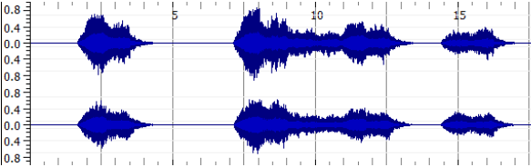

Picture 1

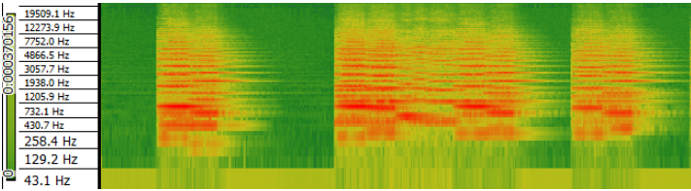

Picture 2